Ph.D. Research Proposal

Doctoral Program in Security Studies

<Ph.D. in Security Studies>

Ph.D. in Force Ratios and Relative Combat Power

Gurkan Yesilyurt

[gurkanyesilyurt@gmail.com](mailto:gurkanyesilyurt@gmail.com)

Advisor:

Date of Submission

Department of Security Studies

Kings College

Abstract&Project Summary

The research project summary should provide an overview of your proposed research project that a non-specialist in the field will be able to understand. It will include the purpose and objectives of the project, why it is important that the issue be addressed and the expected results you hope to obtain.

**Keywords**

**Table of Contents**

**Chapter 1 Introduction**

**Chapter 2 Literature Review**

**2.1.Paragraph**

**Chapter 3 Research Objectives and Methodology**

**Chapter 4 Current Work & Initial Results**

**Chapter 5 Work Plan and Potential Implications**

**Chapter 6 Conclusion**

**References**

**CHAPTER 1**

**Introduction**

Overview of study

Explanation of project background

Briefly focus on primary issues

Why worth to attention

Present: research statement form of hypothesis, goal statement or project statement

Rs:

* capture both essence and limitations of study
* follwed by clarification on the expected outcomes

Introduction: In the proposal introduction you should provide the following:

Research Questions: Explain the question/problem that the project intends to address to put the project in the proper context. You should develop a thesis statements that concisely sums up the question

Research approach: Explain in general the type of approach you will take and why

Significance: Explain why it is important to address the particular

Objectives: Briefly relate what you hope to accomplish through your research project

**CHAPTER 2**

**Literature Review**

**Solid knowledge on the hand**

**You have also established a cohorent and innovative view in sythesizing and integrating the primary aspects in the field, so that put into perspective the new directions that you are planning to explore.**

**Sun Tzu, Art of War III Offensive Strategy[1]**

**Art of Offensive Strategy**

Sun Tzu refers to force ratios on the “Offensive Strategy” part of his book. He emphasizes to capture enemy’s army intact rather than destroying it (p.77, 2nd para). His famous and hard to achieve saying is “for to win 100 victories in 100 battle is not the acme of skill. To subdue the enemy without fighting is the acme of skill (p.77, 3rd para).

By this way he adds the troops are not worn out. This is he terms as the “art of offensive strategy”. From this point he passes to force ratios;

* “When ten to the enemy’s one, surround him (p.79, 12rd para).
* When five times his strength, attack him (p.79, 13rd para).
* If double his strength, divide him (p.80, 14rd para).
* If equally matched you may engage him (p.80, 15rd para).
* If weaker numerically, be capable of withdrawing (p.80, 16rd para),
* And if in all respect’s unequal, be capable of eluding him, for a small force is but booty for one more powerful (p.80, 17rd para).

**Clausewitz, On War** Book III, chapter VIII[2]

* **Superiority of Numbers**,
* Clausewitz refers to “superiority of numbers” as a most common element in victory. According to him strategy decides; time, place, and the forces of the engagement. In is conceptualizing these three factors exert considerable influence on engagement’s outcome (p.194).
* He emphasizes that if purpose and circumstances of the engagement, and the fighting value of the troops is disregarded, then distinguishing factor in battle will be the “number of troops”. In this understanding he points that “numbers” will determine victory. He further adds that when taking into consideration of circumstances, “superior numbers” may actually be contributing very “little” (p.194).
* After this generalization, he further goes and asserts that if superiority reach the point where it is overwhelming, superiority of numbers will be the most important factor in the outcome of an engagement, so long as it is great enough to counterbalance all other contributing circumstances. As a result of this assertion he points out as a **“first principle of strategy”**: bringing as many troops as possible at the decisive point (p.194-195).
* His methodology on building this theory is “historical examples”. Without criticizing whether enough samples are used to make this generalization, I will only summarize that Clausewitz made Marathon as an exception of his assertion where three times strong Persians are defeated by Greeks[3]. Other than that, with examples from Frederick the Great and Napoleon, Clausewitz concludes that: even the most talented general will find it very difficult to defeat an opponent twice his strength. He says that “when we observe that the skill of the greatest commanders may be counterbalanced by a two-to-one ratio in the fighting forces, in ordinary cases, a significant superiority in numbers (it does not have to be more than double) will suffice to assure victory, however adverse the other circumstances”. (p.195). This is my understanding that contemporary doctrine takes the principle which says 3 times strong armies may assault.
* The most important factor is to achieve strength at the decisive point. And it depends on the strength of the army and on the skill with which this strength is employed. Consequently, the forces available must be employed with such skill that even in the absence of absolute superiority, relative superiority is attained at the decisive point. To achieve this, the calculation of space and time appears as the most essential factor. But he says that “although the “equation of time and space” does underlie everything else,
* He further asserts that “conventional jargon” does not allow us to assume “a skillful correlation of time and space explain every instance to beat several forces with a single army” as observed in Frederick the Great and Bonaparte (p.196-197). The true reasons for such victories according to him were the correct appraisal of the opposing generals, taking the risk to engage with inferior forces, energy for rapid movement, boldness for quick attacks, and the increased activity which danger generates in great men. He concludes that these are not related with time and space (p.197).
* Even the ricochet effect of forces to which great generals have frequently entrusted their defense, by which the victories of Rossbach and Montmirail gave impetus to those of Leuthen and Montereau, is, if we wish to be clear and accurate, rare in history. (p.197).
* Relative superiority, that is, the skillful concentration of superior strength at the decisive point, is much more frequently based on the correct appraisal of this decisive point, on suitable planning from the start; which leads to appropriate disposition of the forces, and on the resolution needed to sacrifice nonessentials for the sake of essentials-that is, the courage to retain the major part of one's forces united. This is particularly characteristic of Frederick the Great and Bonaparte. (p.197).
* Superiority of numbers must be regarded as fundamental-to be achieved in every case and to the fullest possible extent. (p.197).
* But it would be seriously misunderstanding our argument, to consider numerical superiority as indispensable to victory; we merely wished to stress the relative importance. The principle is served if we use the largest possible force; the question whether to avoid a fight for lack of strength can be decided only in the light of all other circumstances. (p.197).

Clausewitz refers to superiority of numbers to a condition. So if this condition is not met, which I will analyze in my research, then there must be something else, matters for the victory of the battle.

İf we apply here, marginal benefit concept of economy, increase in one area will not effect after certain point. So here, clausewitz argues that if we deploy overwhlmingly much force then you will guarentee the victory. But I will analyze, how this gradual force accumulation effects victory. Is it increasing as force increase or after some point in comes to stalemate, or it doesn’t effect after one point.

threefold activity of strategy victory lies with adept use of strategy not whole numbers. So deciding when, where, quantity, strategy effects the result. What clausewitz says is it is strategies job to accumulate as much as possible in order to make other factors not be effect. 3ten birine soyutlandığına, sayılar zaferi belirler. Stratejinin işi de diğer iki faktör ne olursa olsun stratejinin işi mümkün olduğunca fazla kuvveti yığmak zaferi garanti etmek diyor.

Angajmanı maksat ve koşul kaynaklı değişkenlerden soyutlarsan numbers determine victory.

Method: observation, deductions.

**Frederick William Lanchester**[4], Aircraft in Warfare, the Dawn of the Fourth Arm

When we come to 1916, a fundamentally new treatment of subject come to the life.

**CHAPTER V: Principle of concentration. The N-Square Law**

* **Principle of concentration:**
  + As Clausewitz refers to bringing as many troops as possible to decisive point as 1st principle of Strategy, Lanchester similarly asserts that one of the great questions at the root of all strategy is that of “concentration”; concentration of all whole resources of belligerent on a single purpose or object, and concentration of the main strength of his forces, at one point in the field of operations (p.39).
  + But unlike Clausewitz he refers material side of concentration as not of principle of strategy rather a scientific phenomenon to be used in tactical operations (p.39). For him concentration has two sides, namely moral and material. He analyses controlling factors of it with the sense of contrasting natures of conditions of ancient and modern warfare.
* **The Conditions of Ancient and Modern Warfare Contrasted (p.40-41):** 
  + According to him in ancient times no matter how much strength strategy brings to the theatre of operations, ultimately men will find only men to wield its weapon. Instead of this direct nature of olden times defence, he argues, defence of modern arms is indirect: enemy is prevented from killing you by your killing him first. “As a consequence of this difference, the importance of concentration in history has been by no means a constant quantity”.
  + Under the old conditions it was not possible by any strategic plan or tactical maneuver to bring other than approximately equal numbers of men into the actual fighting line. Under the present-day conditions all this changed. With modern long-range weapons the concentration of superior numbers gives an immediate superiority in the active combatant ranks. Here he implies that concentration in old times rather difficult to achieve although it was not impossible.
  + In the ancient condition where man is opposed to man, and assuming the combatants to be of equal fighting value and conditions are equal, “duels” will make up the fight and there will be equal numbers killed.
* **Modern Conditions Investigated (p.41):**
  + In the modern conditions, with the same assumptions, each man will in a given time score, on an average, a certain number of hits that are effective, so, the number of men knocked out per unit time will be directly proportional to the numerical strength of the opposing force. He gives also mathematical equation of this like that.
  + He formulates this as:

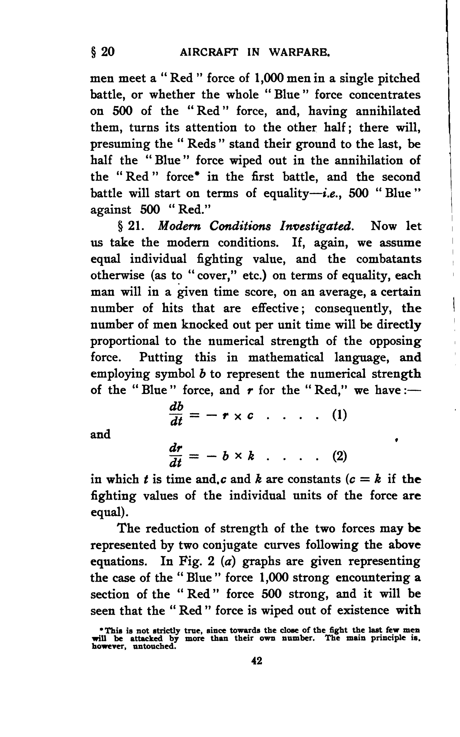

b, r: numerical strength of blue and red

t: time

c, k: constants, (c=k if the fighting values of the individual units of the force are equal)

* **Weakness of a Divided Force** (p.43-46)**:** 
  + He gives graphical explanation of “divided forces” weaknesses. He analyses situations and concludes that if a superior strategy compels one part to fight in two parts, results would be like the conditions explained below;
    - In a 1:1 force ratio, one could defeat the divided side,
    - In a 1:1 force ratio without division of forces battle would prolong,
    - In a 1: √2 superior force ratio, if inferior force divides superior one, the battle end with no winner.
* **Validity of Mathematical Treatment** (p.46-47)**:**
  + After analyzing these force ratios, he further asserts that “the direct numerical comparison of the forces engaging in conflict is almost universal”. He further goes and asserts that “counting the pieces as of value, and to deny the more extended application of mathematical theory, is illogical and unintelligent.”
* **Fighting Units not of Equal Strength** (p47)**:**
  + He made these force ratio analyses with the assumption of fighting strengths of two sides are equal. In mathematical terms c=k.
  + At this point he asserts that “this condition is not necessarily fulfilled if the combatants be unequally trained or of different morale or if their weapons are of unequal efficiency.
  + He asserts that while we cannot judge on these two factors but we can calculate weapons efficiency.
* **Influence of efficiency of weapons** (p.48)**:**
  + He asserts that “any difference in the efficiency of weapons may be presented by a disparity in the constants c and k in equations”.
  + With a Blue force of 500 that use rifle and lose 100 man would eventually be equal force of Red with 1000 man that use breech-loader gun with 200 casualties. Here we have different constants and Lanchester shows this again with mathematical equation.

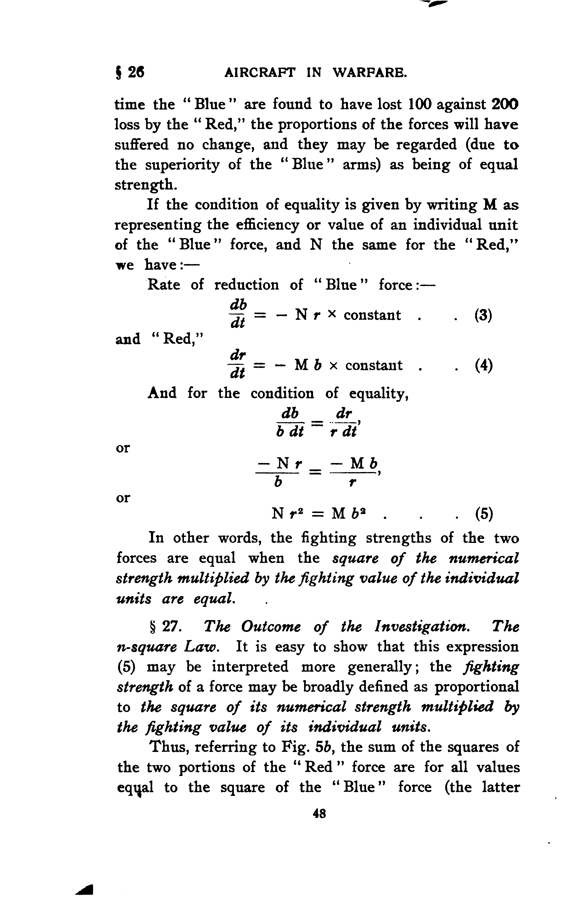

M, N = representing the efficiency or value of an individual unit of Blue, Red Force

* + He explains this formulation as “fighting strengths of the two forces are equal when the square of the numerical strength multiplied by the fighting value of the individual units are equal.
* **Outcome of this investigation: the n-square law and its proof (p.48-50)**
  + Within this law he defines **the fighting strength of a force**: it is proportional to the square of its numerical strength multiplied by the fighting value of its individual units.
  + Thus, (referring to fig. 5b) he made conclusion of divided forces: sum of squares of two portions of the divided forces are for all values equal to the square of the other (not divided) force.

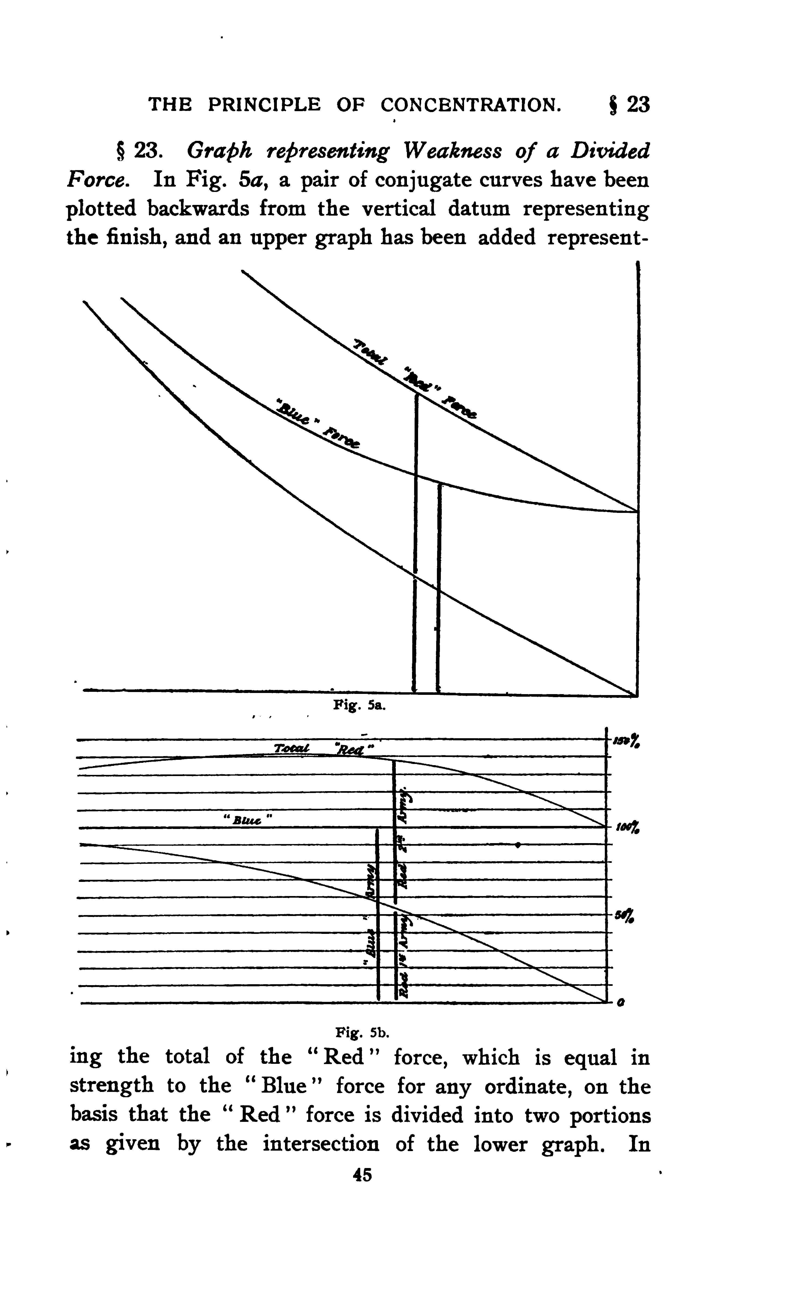

* + **Simple proof of this law arising from equations 1 and 2:** Let the numerical values of the blue and red represented by b and r, then in a small interval of time the change in b and r is represented by db and dr of such relative magnitude that db/dr=r/b or

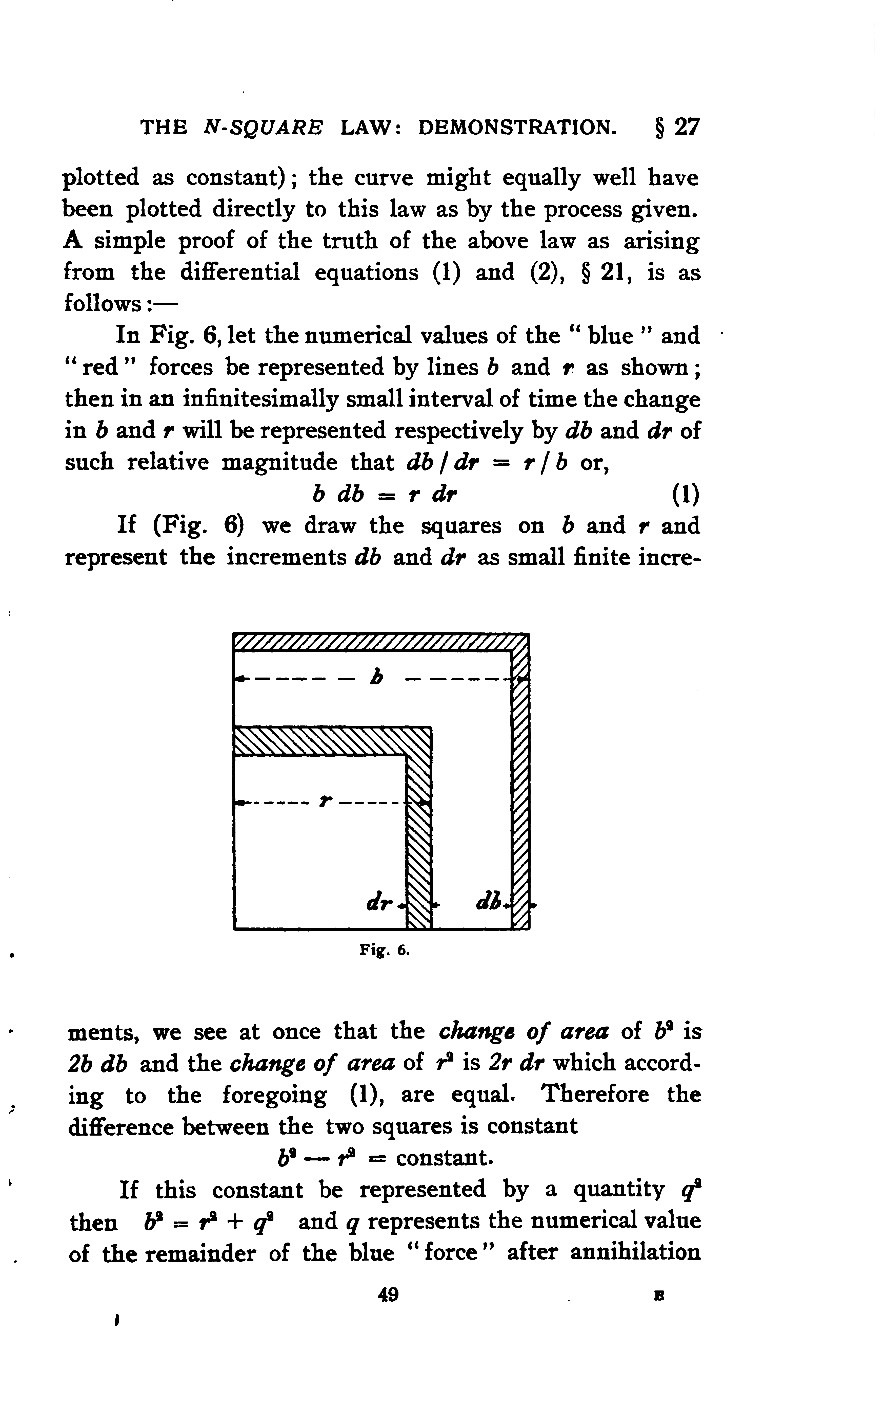

* + If we draw the squares on b and r and represent the increments db and dr as small finite increments, we see at once that the ***change of area*** of ***b²*** is *2b db*, and ***change of area*** of ***r²*** is *2r dr* which according to foregoing (1), are equal.
  + Therefore, the difference between the two squares is constant. q represents the numerical value of the remainder of the blue force after annihilation of the red.

b²-r² = constant ------> b²-r²=q² ---------> b²=q²+r²



* + Example of this is an army of 50K giving battle in turn to two armies of 40K and 30K respectively, equally well armed; then the strengths are equal, since 50K²=40K²+30K². But if divided force fight in one part then the army of 50K will be overwhelmed.
* **Example involving weapons of different effective value:** 
  + He gave an example with this assumption: 1 man employing machine-gun can punish a target to the same extent in a given time as 16 riflemen. He analyzes number of men armed with machine-gun necessary to replace a battalion (1000 men strong) in the field?
  + From n-square law: **N r² = M b² -🡪 16*r²=1*1000²-🡪r²=√1000²/16 = 1000/4=250** or one quarter the number of the opposing force (p.50).
  + According to him this example exhibits at once the utility and weakness of the method. Basic assumption is that the fire of each force is definitely concentrated on the opposing force. Thus, the enemy will concentrate on the 1 machine-gun operator the fire that would otherwise be distributed over four riflemen. And so, on an average he will only last for one quarter the time, and at 16 times the efficiency during his short life he will only be able to do the work of 4 riflemen in lieu of 16 (p.51).
  + When, on the other hand, the circumstances are such to preclude the possibility of such concentration the value of the individual machine-gun operator becomes 16 riflemen. The same applies when he is opposed by shrapnel fire or any other weapon which is directed at a position rather than individual. So, he concludes that one might pay attention to these variations when assessing the theory (p.51). According to him these variations are less common in naval then in military warfare; the individual unit -the ship- is always the gunner’s mark. He points out that aircraft is more similar to navy ship (p.51).
* **The Hypothesis Varied-modifying initial hypothesis to harmonise with the conditions of long-range fire (p.51-52):** 
  + Assumption: fire concentrated on a certain area known to be held by the enemy, and take this area to be independent of the numerical value of the forces, then, with notation as before, we have;

-db/dt = b*Nr*constant

-dr/dt = r*Mb*constant ----->M db/dt = N dr/dt --->or the rate of loss is independent of the numbers engaged, and is directly as the efficiency of the weapons.

* Under these conditions the fighting strength of the forces is directly proportional to their numerical strength; there is no value in concentration, qua concentration, and the advantage of rapid fire is relatively great. This is more likely to ancient warfare.
* **An Unexpected Deduction (p.52):**
  + Better for numerically superior force to come to close quarters,
  + Blue force of 100 men with machine-gun vs red force of 1000 men with rifle
  + 1st assumption: both forces are spread over a front of given length at long range.
  + Red force loses 16 men to the blue force loss of 1 man. Red lose.
  + If red come closer enough for each individual have mark, red would lose half to come closer, **but would win, by n-square law: 600²*1>100²*16**
* **Examples from history (p.53):**
  + Principle: on the field of battle “concentration” matter of the most vital importance.
  + Controlling factors both in strategy and tactic.
  + Attacking of opposing force before concentration gained: defeat of Napoleon in Italy campaign.

**CHAPTER VI: The N-Square Law in its Application**

* The N-Square Law in its Application to a Heterogeneous Force (p.54-55):
  + **chapter V summary:** Fighting strength of a force, so far as it depends upon its numerical strength, is best represented by the square of the number of units.
  + Where individual fighting strengths of the component units (land, navy or air) may be different, it has been shown that if a numerical fighting value can be assigned to these units, the **fighting strength of the whole force** is as the square of the number multiplied by their individual strength. Nr²=Mb²
  + Where the component units differ among themselves, as in the case of a fleet that is not homogeneous, the measure of the total of fighting strength of a force will be the ***square of the sum of the square roots of the strengths of its individual units.***
* **Graphical Representation** (p.55)**:** 
  + The strengths of a number of separate armies of forces successively mobilized and brought into action are represented by the lines a,b,c,d,e, and aggregate fighting strength of these armies are given by the lengths of the lines A,B,C,D,E, each being the hypotenuse of a right-angle triangle, as indicated.
  + Thus, two armies a and b, if acting separately (in point of time), have only the fighting strength of a single force or army represented numerically by the line B.

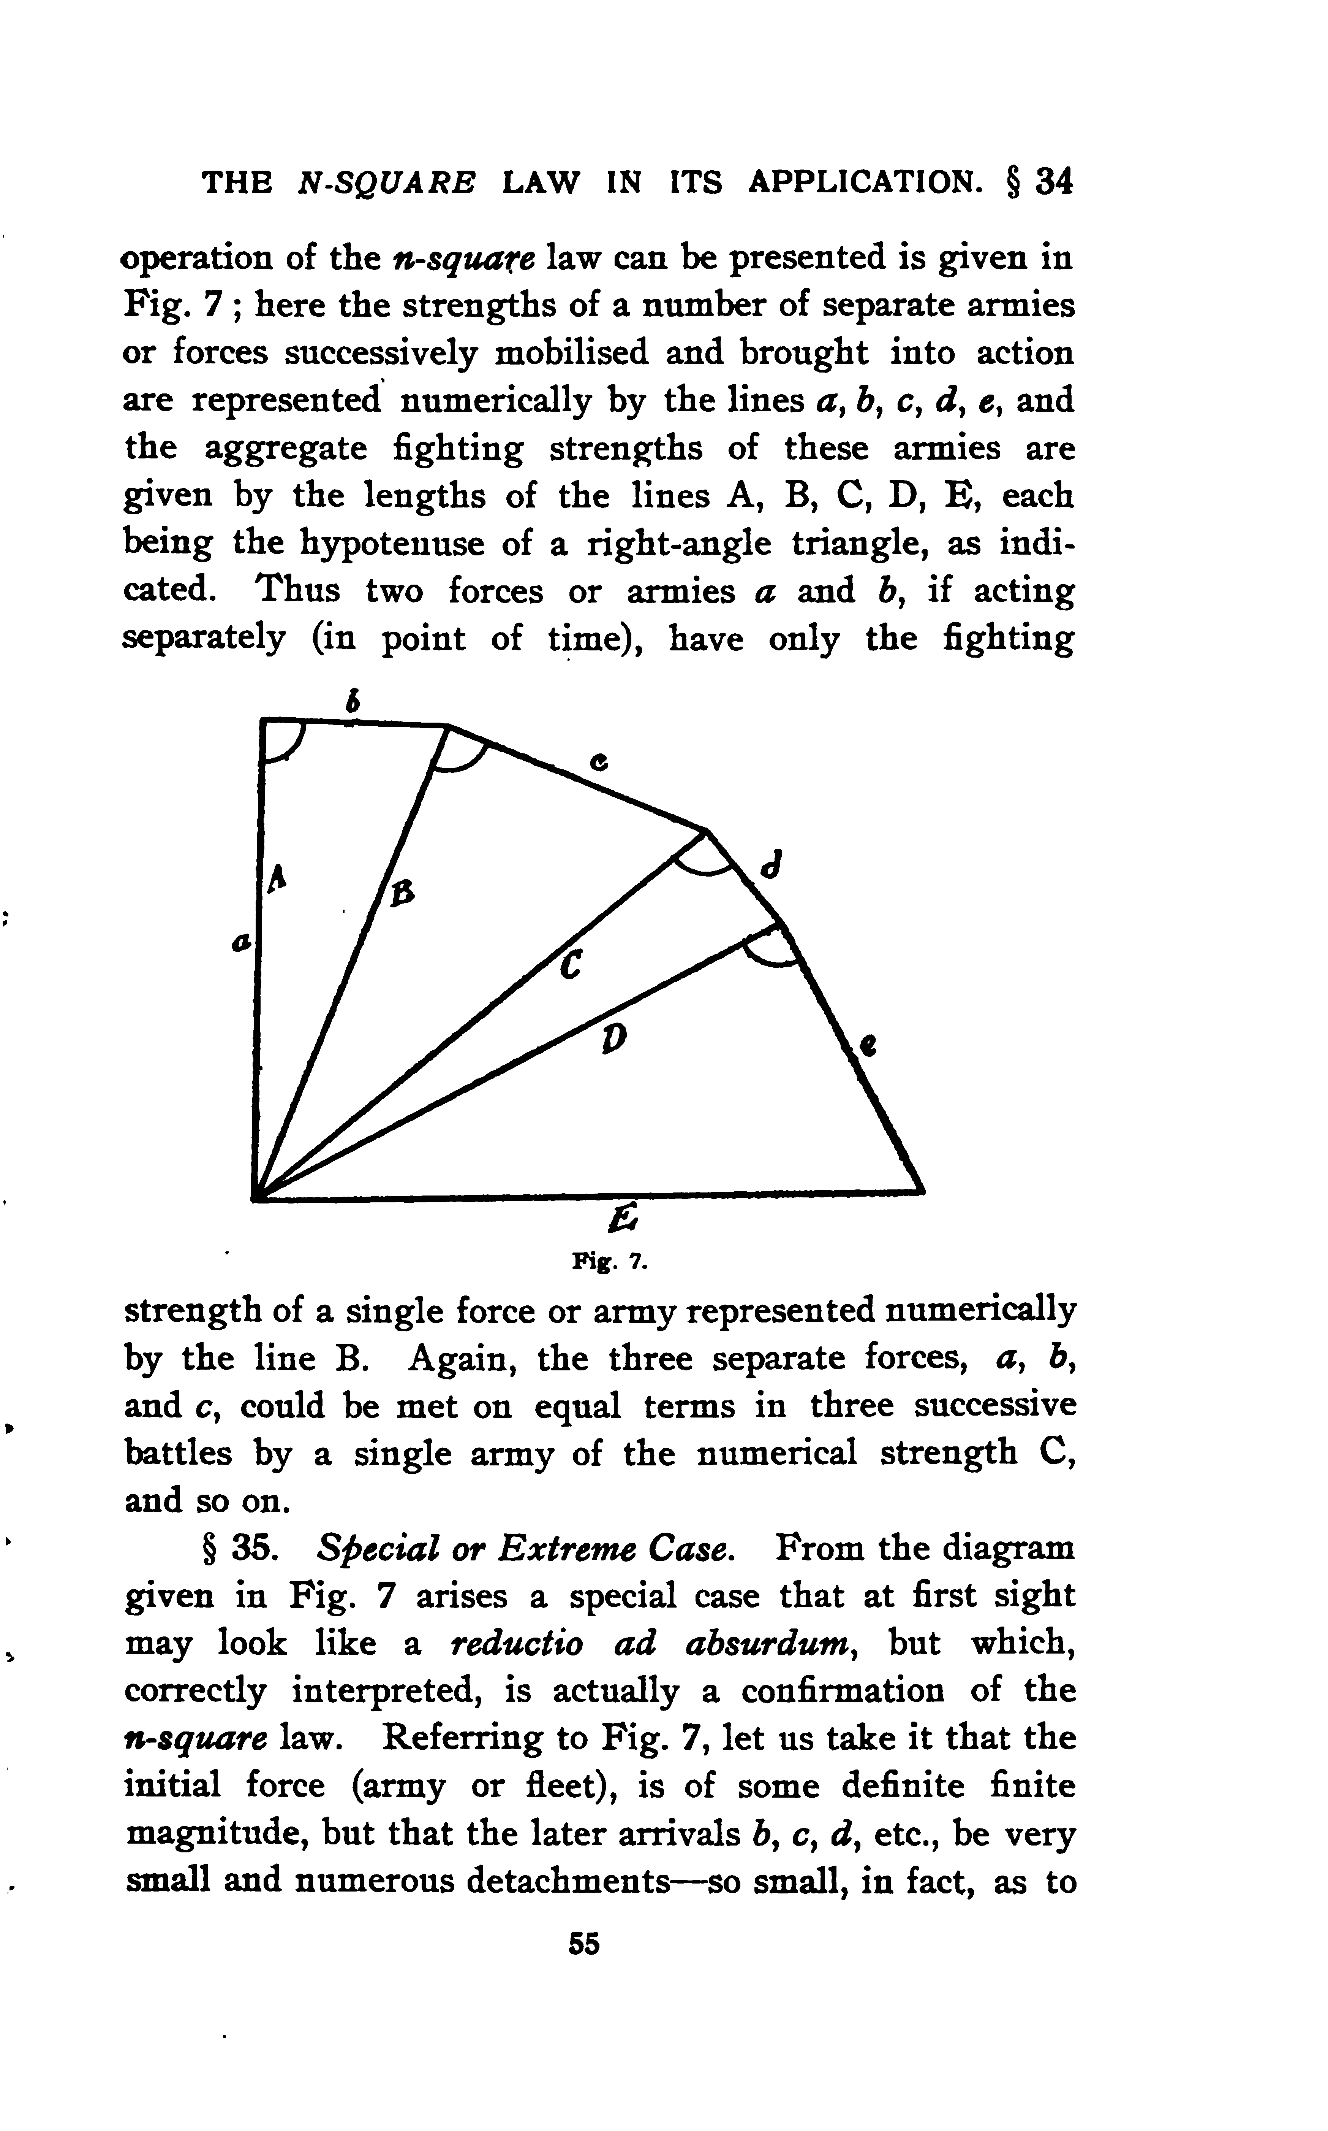

* **N-square law in naval warfare (p.57-58):**
  + N-square law applies to military operations;
    - on land: there may be special conditions to the hypothesis whereby its usage maybe masked.
    - naval warfare: however, the conditions strictly conform to basic assumptions. Thus, when battle fleet meets battle fleet, there is no advantage to the defender analogous to that secured by the entrenchment of infantry.
  + In a naval battle every shot fired is aimed at one enemy’s ship; there is no firing on the mass.
  + Old conditions (1000-yard effective range): advantage could be taken of concentration within limits. 18th century tactics makes it apparent that with any ordinary disparity of numbers (probably in no case exceeding 2 to 1) the effect of concentration must have been not far from that indicated by theory.
  + With a battle-fleet action at the present day the conditions are still more favorable to the weight of numbers, since with the modern battle range-some 4 to 5 miles- there is virtually no limit to the degree of concentration of fire.
  + Further than this, there is in modern naval warfare practically no chance of coming to close quarters in ship-to-ship combats, as in old days.
  + Thus, the conditions are to-day almost ideal from the point of theoretical treatment. Numerical superiority of ships of individually equal strength will mean definitely that the inferior fleet at the outset has to face the full fire of the superior.
  + The same observations will probably be found to apply to aerial warfare when air fleets engage in conflicts, more especially so in view of the fact that aeroplane in three dimensions of space instead of being limited to two, as in the case with the battleship. This will mean that even with weapons of moderate range the degree of fire concentration possible will be very great.
* **Individual value of Ships or Units (p.59):** 
  + Deciding the value of individual units is difficult.
  + Fighting value of ship depends not only to armament but also to protective armor. Question of fleet strength can never be reduced quite a matter of simple arithmetic.
  + May be gauged by the weight of its “broadside” or more accurately, taking into account the speed with which the different guns can be served, by the weight of shot that can be thrown per minute.
  + Another basis may to compare energy per minute for *broadside fire*, which represents, the horsepower of the ship as a fighting machine.
  + Similar means of comparison for aeroplane, though it may be that the *downward fire* capacity will be regarded as of vital importance.
* **Applications of the n-square Law (p.59-61):**
  + The **n-square law** tells us at once the price or penalty that must be paid if elementary principles are outraged by the division of battle fleet into two or more isolated detachments.
  + If battle fleet separated into 2 equal parts, increase would require to be fixed at approximately %40 percent – that is to say, in relation of 1 to √2; more generally the solution is given by a right-angled triangle.

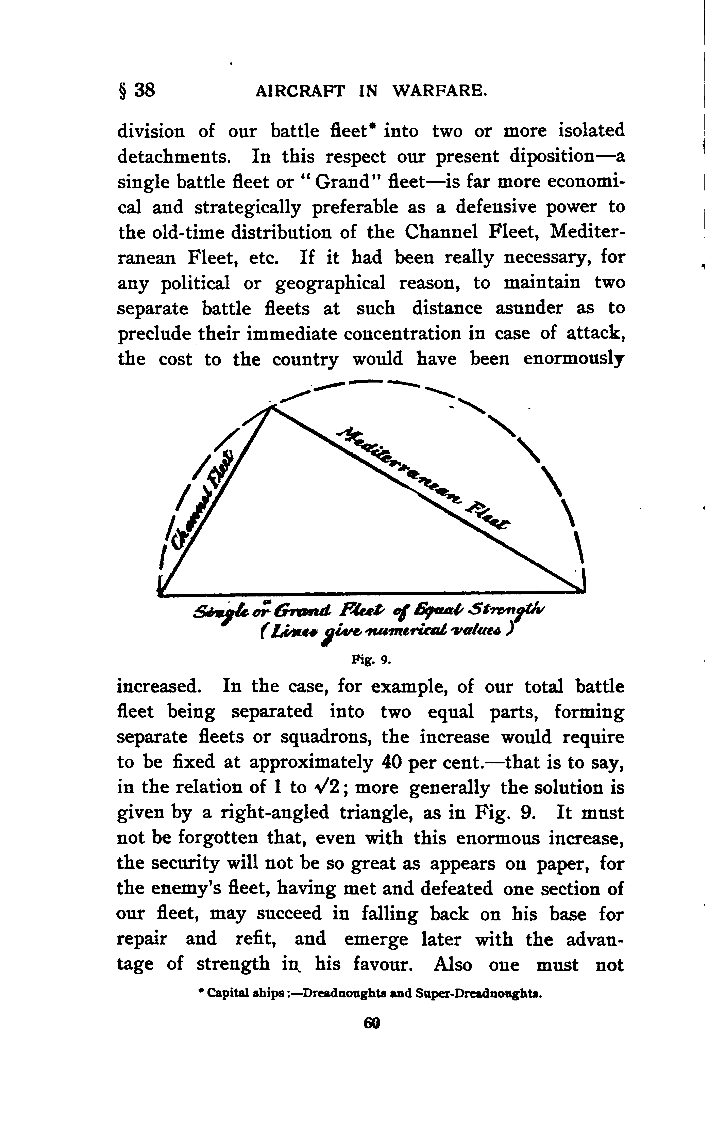

* **British Naval Tactics in 1805 (p.62):**
  + Not form in a line-of-battle parallel to the combined fleet
  + Break the line, envelop rear, overpower with groups of ships, isolate enemy and cut off.
  + First tactics according to Lancaster, advantages of fire concentration.
  + Van cannot help rear
* **Nelson’s Memorandum and Tactical Scheme (p.63, 64):**
  + British formed 2 main columns.
  + One of the main columns was to cut the enemy’s line about the centre,
  + Other to break through about 12 ships from the rear,
  + Smaller column being ordered to engage the rear of the enemy’s van 3 or 4 ships ahead of the centre, and to frustrate, every effort the van might make to help centre or rear.

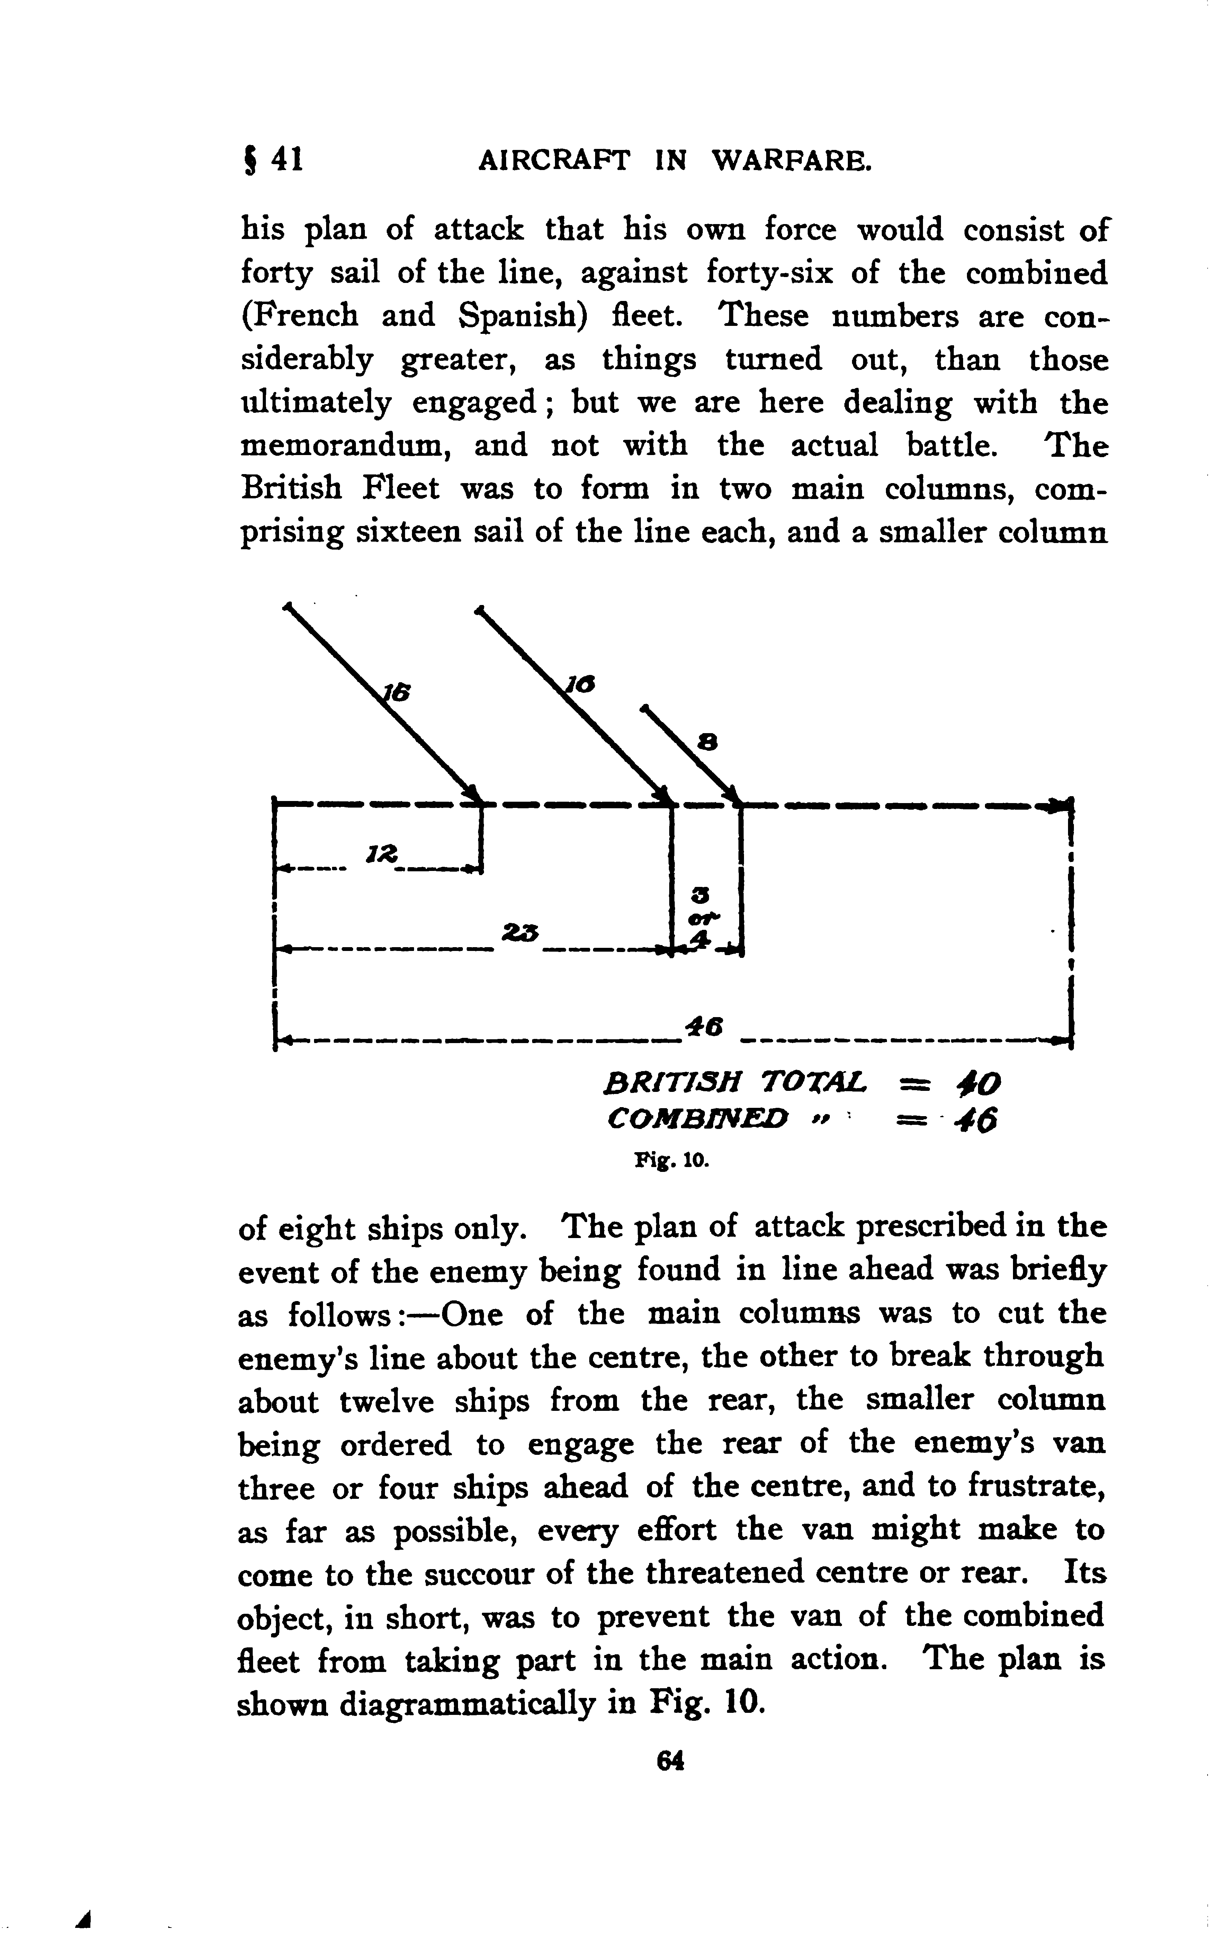

* **Nelson’s Tactical Scheme Analysed (p.65-66):**
  + Nelson planned to envelop the half of -23 ships- combined fleet with 32 ships. This, according to n² law would give him superiority of fighting strength of almost exactly 2 to 1[5].
  + Strength of British in arbitrary n² units:32²+8²=1088
  + Combined fleet: 23²+23² = 1058
  + British advantage:30, remaining British ship: √30=5.5 ships
  + If they had engaged in older times tactics:
  + strength of combined fleets 46²=2116
  + strength of British fleets: 40²=1600, Balance in favor of combined fleet would be 526, in ship terms √516= 23.
  + Thus, we are led to appreciate the commanding importance of a correct tactical scheme. If old-time method of attack had been adopted, British could not avert defeat.
  + First: Definite statement of cutting the enemy into two equal parts – according to n-square law the exact proportion corresponding to the reduction of his total effective strength to a minimum
  + Second: the selection of a proportion, nearest whole number equivalent to the √2 ratio of theory, required to give a fighting strength equal to tackling the two halves of the enemy on level terms, and the detachment of the remainder, the column of 8 sail, to weaken and impede the leading half of the enemy’s fleet to guarantee the success of the main idea.

**CHAPTER VII: Attack by Aeroplane on Aeroplane. The Fighting Machine and Its Armament**

* **Attack by Aeroplane on Aeroplane (p.67-68):**
  + Lancester emphasize that in the 1St World War period main duty of aeroplane was reconnaissance, but he foresaw that by the next war they will be used to attack each other.
  + He says that, with the technology by this time, it is not easy to attack to aeroplane on the air. So, it is not easy to give casualties to enemy.
* **The Fighting Machine as a Separate Type (p.68-69):**
  + Long distance reconnaissance flights or strategic scout should not be deemed fighters, but tactical scout should be engaged by enemy so it has to defend itself or some other fighters defend scout planes.
  + So, he foresaw need of rendering the tactical reconnaissance type capable of taking the offensive, so that it may establish its ascendency over the similar craft of the enemy.
  + But he emphasizes heavily armed fighting machine will provide air supremacy. Until this time tactical scout is playing double role (recce and fighting).
* **The Question of Armament; Treaty Restrictions (p.70-72):**
  + Int the specification of a fighting type of aeroplane the consideration is means of attack. These fall two main categories:
    - fire-arms (machine-gun, mitrailleuse) and
    - gravitational weapons (bombs, grenades etc.)-ill suited to conditions of aircraft.
  + Light artillery may be mounted, but only the very smallest calibre -namely, the “one pounder” can be considered suitable for present day machines.
  + The use of smaller size of projectiles is prohibited by treaty obligation. Any explosive projectile less than 1 lb. weight (400 gr) is banned by the Declaration of St.Petersbourg of 1868.

**CHAPTER VIII: Rapidity of Fire and Its Measure**

* **Rapidity of Fire and Its Measure (p.77-78):**
  + Index of fighting value: rapidity of gun-fire from aeroplane or dirigible depends on nature of target.
  + Some cases: number of projectiles per minute is most important factor, as, for example, in attacking any object in which hit is hit whether the projectile be large or small.
  + Other cases: where the mischief done is in any reasonable relation to the weight of the projectile, the total weight of projectiles discharged per second affords better criterion.
  + In view of comparatively fragile nature of aircraft, it is doubtful whether the energy equivalent of the discharge will ever be of the importance which it in the case of the battleship, where the destruction of the enemy depends to a very large extent upon the number of foot-tons with which he is assailed.
  + Thus, it is doubtful whether a factor representing the hp of the offensive armament would, as applied to the fighting aeroplane, will have any useful significance.
  + Not probable, fighting machine have complete bullet proof protection, at short range. So unimportant which bullets used in its destruction. Weight and size is only important when a single hit is sufficient to carry away an important structural member which would have been penetrated without great injury by a bullet of ordinary size.
  + So long as we are dealing with ordinary rifle, pistol or mg fire, we are concerned merely with the ***number of bullets that can be discharged per unit time***. This number express **value of armament.**
* **Measure of Fire Value in the case of Explosive Projectiles (p.78-79):**
  + In the context of throwing explosive projectiles, it is impossible to maintain any direct basis of comparison.
  + Effectiveness of the shell fire depends upon the conditions (range must be known, time-fuse mechanism perfect, nature of target).
  + Granted that necessary conditions exists, destruction wrought by any given type of explosive projectile maybe taken as, in a measure, proportional to its weight. However, there are cases where 3 lb. high explosive maybe effective than 18 lb. if hit at the motor.
  + Comparing the relative value of armament of diverse type for aeroplane (mg or small artillery) we need to examine the service for which the armament is required; it is impossible to institute a direct quantitative comparison which would be generally applicable.

**Chapter 3 Research Objectives and Methodology**

Detailed account of how you intend to conduct your research.

Discuss equipment, tools, techniques and anything else that will be used in conducting project.

You won’t be expected to know precisely everything involved but you will need to demonstrate that you have given it serious thought.

**Chapter 4 Current Work & Initial Results**

**Chapter 5 Work Plan and Potential Implications**

outline of your proposed time frame with specific targets at certain intervals.

Make sure your proposed time frame fits within the programs schedule to complete a PhD.

This section isn’t always required or may be combined with the methodology section. Check with specific programs for their requirements.

**Chapter 6 Conclusion**

**References**

Bibliography: This is a page of all references that you have used, will use or think you might use in your research project including the literature review. The bibliography will be used to determine if you have a good background in the relevant literature and haven’t overlooked an important source. Use the citation style appropriate for your particular field.

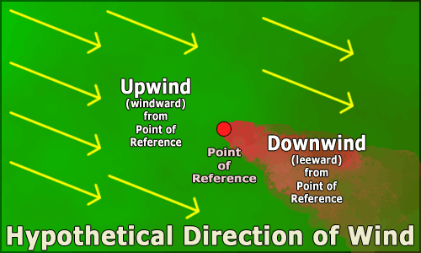

1. TZU, Sun. The Art of War, Translated and with an Introduction by Samuel B.Griffith, Oxford University Press.
2. Clausewitz, Carl Von. On War, Edited and Translated by Michael Howard and Peter Paret, Princeton University Press, Princeton, New Jersey, 1984.
3. History Channel, 2006, A&E Television Networks, Decisive Battles-Battle of Marathon: <https://www.youtube.com/watch?v=V3b6M5CzYTE>, 16 January 2021.
4. Aircraft in Warfare, F.W.Lanchester, London, 1916.
5. Though explanation is given like this: 23*√2=32.5, means since combined fleet is divided, they need √2 plus force to make equation with the UK fleet. I make this deduction to reach 2/1 force equation: 32²=23²+23², thus in the first battle would be fight with 32²=23² this portion. Equals to 1024 vs 529.